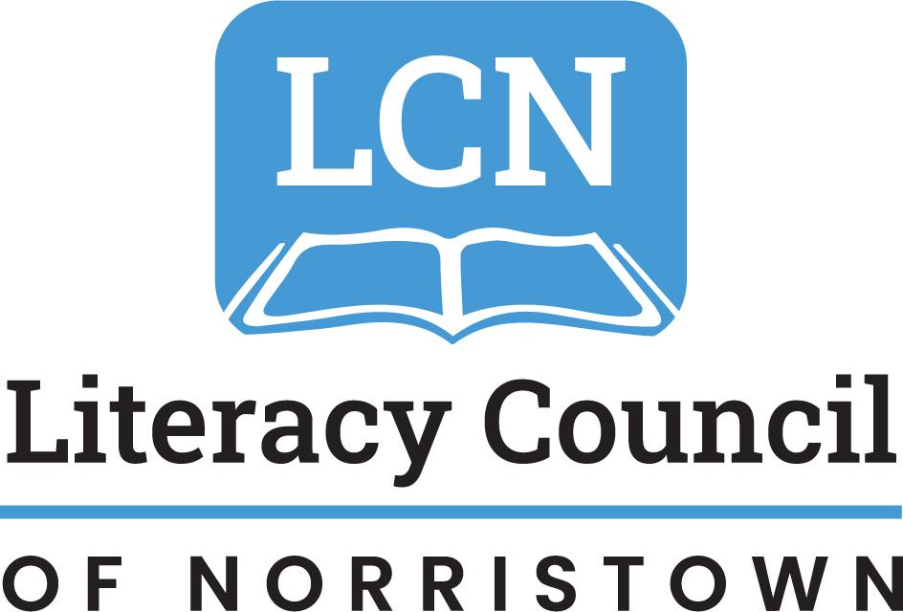

Volunteer Literacy Tutor

HANDBOOK

Teaching adults and supporting families in Norristown and greater Montgomery County since 1984.

Table of Contents

- LCN Contact Information and Mission Statement p.2
- LCN Programs p.3
- “Why Does Literacy Matter?” P.4
- “How Literacy Programs Help Produce Positive Outcomes” p.4
- Volunteer Tutor Role and Qualifications p.5
- Who is a Volunteer Literacy Tutor for adults? p.6
- Tutor Policies and Guidelines p.8
- Cautions/Caveats p.10
- Adult Learners are Different that Child Learners p.11
- Characteristics of Adult Learners p.12
- Tips for Working with English Language Learners p.13
- 21 Tips for Effective Tutors p.14

Welcome to LCN!
We are so grateful for the thousands of hours and the rich variety of skills and talents our volunteers contribute every year. We truly could not do it without you!

LCN Volunteer Literacy Program Contact Information

Mailing Address:
Literacy Council of Norristown
113 East Airy Street
Norristown, PA 19401
www.lcnlit.org
610-292-8515
LCN Staff:
Eileen Hallstrom, Executive Director
executive.director@lcnlit.org

Lorena Carlson, Assistant Director/GED Manager
lorena.carlson@lcnlit.org

Chrysa McKelvey, Assistant Director/Tutor Training
chrysa.mckelvey@lcnlit.org

Nancy DiSarlo, Student-Tutor Coordinator
nancy.disarlo@lcnlit.org

Jodi Lambright, Student-Tutor Coordinator
jodi.lambright@lcnlit.org

Claudia Cervantes
barleyminds@gmail.com

Mission Statement

The Literacy Council of Norristown (LCN) was founded in 1984 in Norristown by a group of volunteers who wanted to improve lives through literacy. LCN supports adult learners with the reading, speaking, writing, math, English, and work skills they need to access broader social, employment, and educational opportunities. Literacy empowers learners, their families, their employers, and the Montgomery County community at large. Today, the mission of LCN is to improve lives and strengthen families in greater Norristown and Montgomery County by providing adult literacy and English language programs. We serve learners from all over Montgomery County.

LCN Programs include:

Adult Basic Education (ABE): This program supports adults looking to improve their reading, writing and math skills. Learners are matched with LCN-trained tutors and these learning pairs work up to three hours per week together on a learning journey overseen by LCN. Tutors attend 12-hours of training provided by LCN

High School Equivalency/GED (HSE/GED): Adult learners enroll in a combination of one-on-one tutoring and targeted classroom instruction to tailor their learning journey for success. LCN supports learners with instruction, learning materials, and covers the exam fees for learners. Instruction and testing is available in both English and Spanish.

English as a Second or Other Language (ESL): LCN’s English language classes enable students to improve their basic skills of reading, writing, listening, and speaking English. Additional resources include Conversation Clubs, citizenship tutoring and support, as well as connections to legal, housing, food, health, and other forms of aid.
Digital Navigator Program: LCN connects adults to digital resources including computer classes, basic tech support, online programs, free or low-cost internet, and low-cost computers

Community/Family Literacy Programs: LCN works with community members and organizations, including businesses, libraries, and nonprofits to bring literacy instruction directly to learners onsite. Additionally, LCN partners with multiple family literacy partners to bring free books, learning resources, and workshops directly to families in the community.

Why Does Literacy Matter?
“Literacy is the ability to identify, understand, interpret, create, communicate, and compute, using printed and written materials associated with varying contexts. Literacy involves a continuum of learning in enabling individuals to achieve their goals, to develop their knowledge and potential, and to participate fully in their community and wider society.” UNESCO 2017

“How Literacy Programs Help Produce Positive Outcomes”
Excerpted from ProLIteracy America @ www.proliteracy.org

- There is a direct correlation between parents’ educational levels and how a child performs in school
- The single greatest predictor of a child’s literacy is the mother’s literacy level.
- The best way to ensure that children find success in school is to address the literacy needs of the adults in their lives.
- Linguistically-rich home environments contribute powerfully to the early development of a child’s literacy skills. Adult and family literacy programs help to create these “linguistically-rich” environments.
- Advancing an Educational Functioning Level (EFL) can add $10,000 to an individual's annual income; adding a GED amounts to an additional $9,000.

When parents engage in adult literacy programs:
- They pass on the idea that education is valuable.
- They become more involved in the schools and their child’s learning at home.
- There are long-term gains for their children: fewer nutrition and health problems, lower drop-out rates, fewer teen pregnancies, less joblessness, and less social alienation.
- There is a direct correlation between improved literacy skills and child survival rates.
- More literate parent(s) become better advocates for their families.

Volunteer Tutor Role and Qualifications

Purpose:
- Help an adult, age 18 and older, improve his/her basic literacy skills (reading, writing, speaking, listening, math and/or computer skills)
- Help the students use newly-learned skills to meet identified goals

Training:
- Attend one orientation session
- Complete four tutor training sessions
- Ongoing training and support as you work with your learner

Qualifications:
- Be at least 18 years of age
- Be able to speak and understand English well enough to communicate with ease
- Read at a 12th grade level or above
- Be dependable, prompt, interested in helping others, sensitive to different backgrounds and cultures, patient and optimistic
- Maintain confidentiality
- Commit to the program for at least one year to allow for the tutor/student pair to build trust and make progress
Hours:
Ideally, the tutor and student should try and meet twice a week for 1-1.5 hours each time. Many tutors meet once a week for 1-2 hours each. We understand and expect volunteers and students to take vacations and breaks.

Who is a Volunteer Literacy Tutor?
Someone who is willing to commit time and energy to the student and program training. You believe that good literacy skills improve lives, break down isolation and help people make better decisions. You don’t need a teaching background to be a successful tutor, or speak a foreign language to help a non-English speaking person to learn English.

A successful literacy tutor has the following characteristics:
- Good communication and interpersonal skills
- Ability to encourage and inspire trust
- Awareness of cultural differences
- Respect for the student as an adult peer
- Ability to deal with ambiguity
- An understanding that there is no one way to learn or that all students learn alike
- Willingness to abandon traditional methods of teaching if needed
- Sense of humor
- Patience and flexibility
- Enthusiasm for learning
- Ability to keep confidentiality
- A basic understanding of the barriers to literacy and the complexity of our students’ lives and schedules

Is the role of literacy tutor right for you?
Many times you will see measurable success with your student, but sometimes the barriers that our students face prevent them from reaching their goals. The tutor must understand that his/her expectations/experience with a traditional instructional path may not be appropriate for the adult literacy student. Sometimes your role as a tutor is more coach than instructor, offering encouragement and hope that a student can make progress. Sometimes the tutor may not see the results of his/her work. Barriers to literacy and techniques to overcome them are discussed in tutor trainings.

Benefits to becoming a volunteer tutor:
- Opportunities to learn from a peer
- Making a difference in someone’s life that will have an impact on their family’s future
- Meeting and working with friendly, action-minded people; belonging to a group of dedicated volunteers
- Personal growth
- Cultural exchange
- Satisfaction gained from helping others
- Work satisfaction and a reference for your resume
Tutor Policies and Guidelines

Tutor Policies
- Maintain confidentiality. Any discussion pertaining to a student should only be held in private with the LCN literacy coordinator.
- Tutor should report any concerns to the coordinator.
- If your student has personal problems or needs a referral for other services, notify the literacy coordinator rather than getting involved yourself.
- Do not bring children or guests to the tutoring sessions. Students have been given the same instructions; however, sometimes there is an exception when both tutor and student agree.

Tutor Guidelines
- Complete tutor training workshops
- The literacy coordinator will assign you a student and set up your first meeting.
- The coordinator will be in contact with you and your student periodically to assess progress, help overcome difficulties and give advice on plans for further tutoring.
- Exchange phone numbers/email addresses with your student as soon as you feel comfortable doing so.

Tutor Responsibilities
- Attend a 12-hour Tutor Training Workshop.
- Meet with your student at least 1-2 hours weekly at a mutually convenient public location.
- Submit tutoring and tutoring prep hours every month.

Tutor Boundaries
- Providing gifts, money, favors or food to students is not recommended.
  - We realize that it may be appropriate to give a small gift in recognition of an accomplishment or a holiday. Please carefully think through how appropriate your gift is. Try to choose a gift that is low in cost or homemade.
- If a student has expressed a need or you have witnessed a need, encourage the student to contact LCN staff who can provide or refer the student to the appropriate resources.
- Tutor/student pairs should meet in an open, public location. LCN is available as a meeting place during regular office hours.

Tutor Dismissal Policy
A tutor may be dismissed for misrepresenting his/her qualifications and/or not completing training, not complying with stated responsibilities, or disregarding tutor policies.

Non-Discrimination Policy
The Literacy Council of Norristown is an affirmative action, equal opportunity institution.

Tutors need to be aware of and prepare to alleviate/respond to the following challenges:

- Adult literacy students tend to be intimidated by formal tests. In our program students are “assessed,” which means they are given assessments that indicate a level of expertise. There are no pass/fail tests in the program, only indications of the basic levels they begin at and if they have progressed or not.
- Adult students are often apprehensive and nervous, fearing they will be considered stupid.
- Adult students dislike being treated as children and learn best in a peer relationship.
- Many adult students have had unpleasant experiences with the education system.
- Many immigrant students have had little formal instruction in their home countries and lack knowledge of learning conventions.
- Adult learners often have busy work/family schedules, have to respond to pressing childcare/budgetary concerns and sometimes lack reliable transportation.
- Adult learners may have undiagnosed learning disabilities.
- Our students may experience slow progress due to frequent disruptions and little time to study.
- Monitor your expectations about what progress a student should be making; our students tend not to make progress in a traditional trajectory.
- Our students often have other issues in their lives that a literacy program cannot address.

Adult Learners are Different from Child Learners

- Adults have more life experience that can be utilized to aid literacy instruction.
- Adults enjoy having their talents and experience made use of in a teaching situation.
- Adults learn best when treated as a peer.
- Adults attend classes with a mixed set of motives.
- Adults are largely self-directed.
- Adults can be rigid and reject information that conflicts with their established beliefs.
- Adults’ expectations about learning vary, depending on past experiences.
- Adults learn in order to meet immediate needs and goals.
- Adults need to perceive their time as being well spent and productive.

Characteristics of Adult Learners

Adults are autonomous and self-directed.
Adult learners need to be free to direct themselves. Tutor must actively involve adult students in the learning process. It is necessary to get learners’ perspectives about what topics to cover and let them work on projects that reflect their interests. It is important that the learner understand how the tutoring sessions will help them reach their goals.

Adults have accumulated a foundation of life experiences.
Successful tutors tap into the knowledge and experience that adult learners bring to the program, just as successful readers connect background knowledge to the new material they are reading. English language learners progress more quickly if we teach and tie new vocabulary to past and present experiences.

Adults are goal-oriented.
Learners enroll in literacy programs for a reason. They appreciate an organized program that has clearly defined elements. Identifying goals should be one of the first things established between tutor and learner. It is important to remember that goals can and do change.

Adult learners are focused on relevant and practical tasks.
Learning must be applicable to work and other responsibilities. Adults have busy schedules and limited study time.

Adults need to be shown respect.
Adults should be treated as equals in experience and knowledge.

TIPS WHEN WORKING WITH ENGLISH LANGUAGE LEARNERS
LISTEN.
Remember that your student, rather than you, needs to practice speaking. Your job is to extract language from the student, not to lecture.

PERSONALIZE.
Talk about topics that relate to the student’s personal world and background. Find common ground.

KEEP IT LIGHT.
Learning a new language is hard and tiring work, especially after finishing your “day” job. Remember that we learned our native language through family interactions.

ENCOURAGE.
You’ll find that your student doesn’t like to make errors; however, learning a new language is nothing if not a process of making mistakes. It is a daunting and frustrating procedure and your student needs every bit of encouragement s/he can get.

REVIEW.
Once, twice, thrice…it’s never enough when learning a new language! Make sure your student has plenty of opportunity to practice. Keep a record of what you and your student have covered so you can start each lesson with a short review. Think of ways to present the lesson in a different format. It’s preferable to do a little bit well, rather than a lot superficially.

DON’T OVERCORRECT.
Don’t belabor any one point or pronunciation topic. Sometimes we never learn how to say it like a “native.” Communication and comprehension are what’s important.

20 Tips for Effective Tutors

- Relax and be yourself!
- Establish rapport.
- Maintain confidentiality.
- Alleviate student embarrassment and shyness.
- Have patience.
- Bring a positive attitude to the session.
- Share your knowledge and experience.
- Be on time.
- Be creative and imaginative; vary lesson activities.
- Be flexible! Have a plan B - and maybe plan C !
- Avoid a patronizing tone and attitude.
- Spend more time listening, rather than talking. Tutoring is not a lecture course.
- Celebrate big and small gains.
- Learn from your student
- Allow learners to discover the answer on their own.
- Keep accurate records.
- Make corrections gently and don’t belabor any one point.
- Remember that you don’t have all the answers - and it’s ok!
- When all else fails, call the coordinator.
- HAVE FUN!

